Name: B.Vinayani
Registration Number: 192472179

EXPERIMENT 7
Text Generation using Google Gemini LLM API

AIM
To develop a Python program using the Gemini API to generate responses for different user prompts and display the generated output.

PROCEDURE
1. Open Google AI Studio and create a Gemini API key.
2. Install the Google Gen AI library using: pip install google-genai
3. Store the key in an environment variable named GEMINI_API_KEY.
4. Write a Python program that creates a genai.Client and defines a list of different prompts.
5. For each prompt, call client.models.generate_content() with the chosen Gemini model and read response.text.
6. Display every prompt with its generated response, run the program and capture a screenshot of the output.

CODE
exp7_gemini.py
"""Experiment 7 - Text generation using the Google Gemini LLM API."""
import os
import sys

from google import genai

MODEL = "gemini-2.0-flash" # change to any Gemini model available to your key

PROMPTS = [
"Write a two-line poem about the Moon.",
"Explain the difference between AI and Machine Learning in simple words.",
"Give three tips to prepare for a technical interview.",
]

def get_client():
api_key = os.getenv("GEMINI_API_KEY")
if not api_key:
sys.exit("Error: set the GEMINI_API_KEY environment variable first.")
return genai.Client(api_key=api_key)

def generate_response(client, prompt):
"""Return the text generated by Gemini for the given prompt."""
response = client.models.generate_content(model=MODEL, contents=prompt)
return response.text.strip()

def main():
client = get_client()
print(f"Model: {MODEL}")
for number, prompt in enumerate(PROMPTS, start=1):
print(f"\n[{number}] Prompt: {prompt}")
try:
print("Response:")
print(generate_response(client, prompt))
except Exception as err:
print(f"API error: {err}")
print("-" * 60)

if __name__ == "__main__":
main()

OUTPUT
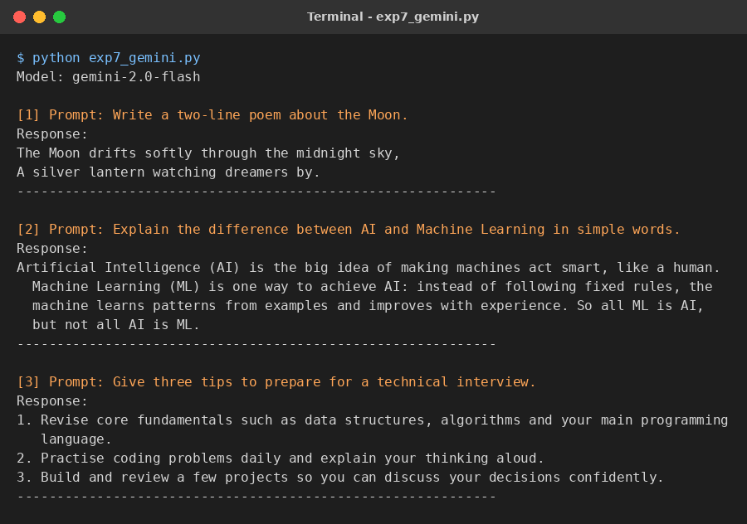
Figure 1: Sample output of the program

RESULT
The Python program used the Gemini API to generate responses for three different prompts (a creative task, an explanation and a list) and displayed each generated output.

CONCLUSION
The Gemini API provides a simple way to generate text from Python. The same program structure works for creative, explanatory and list-style prompts, showing the flexibility of the model.

